Lush, Alan Robert
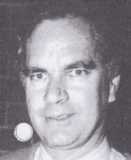
BSc Forestry ANU, graduated 1971. Commenced as Assistant Divisional Forests Officer with W.A. Forests Department in 1972. Worked in Perth, transferred to Wanneroo in 1972. Transferred to Kelmscott Inventory and Planning in 1974. Worked in Manjimup Inventory & Planning in late 1970s-80s. Promoted to District Manager Manjimup in 1990. Later Deputy Regional Manager Southern Forests Region. After CALM was formed, moved to Forest Production Commission.

